SKILL (WEEK-2)

- Create Table
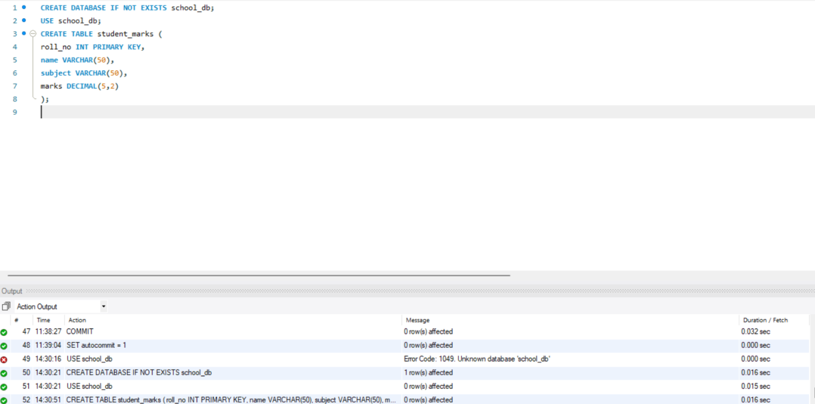
- Insert Initial Data
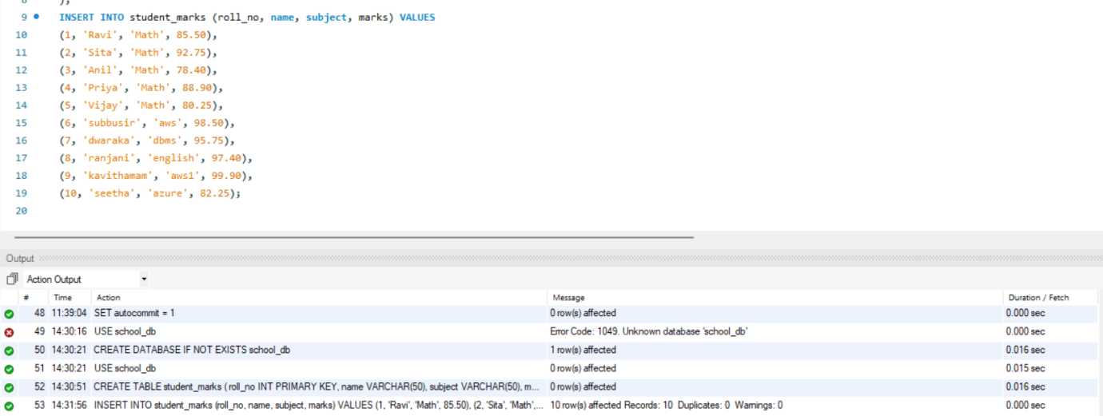
- Simple Selection
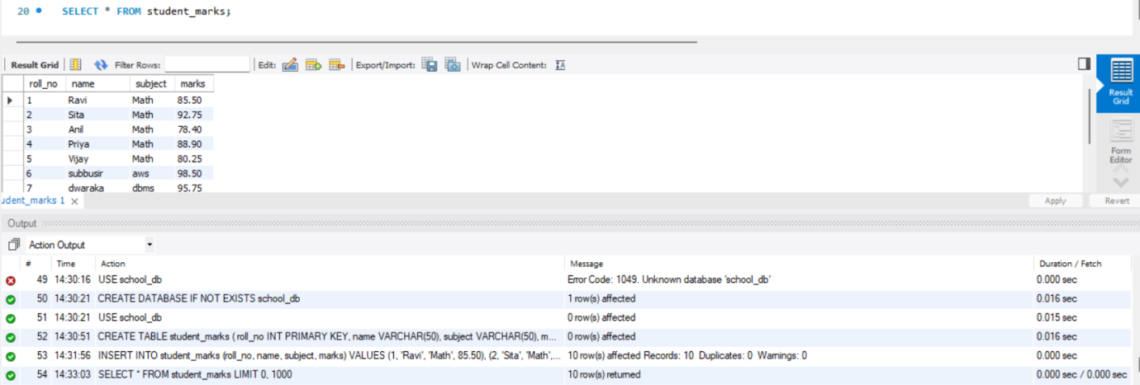
- Total Student Count
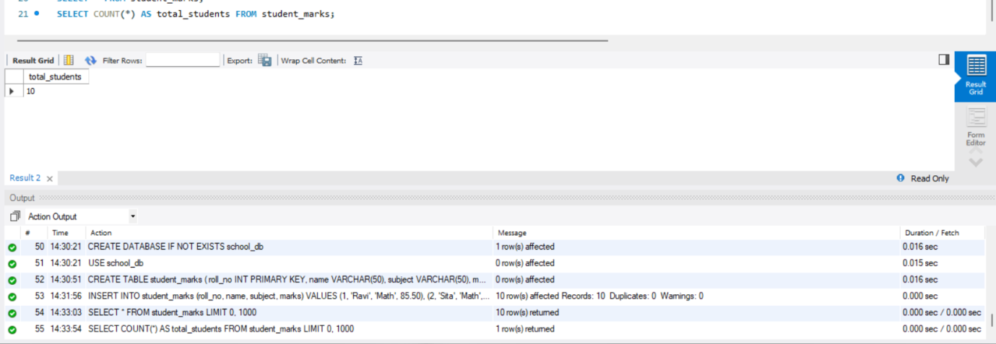
- Sum of All Marks
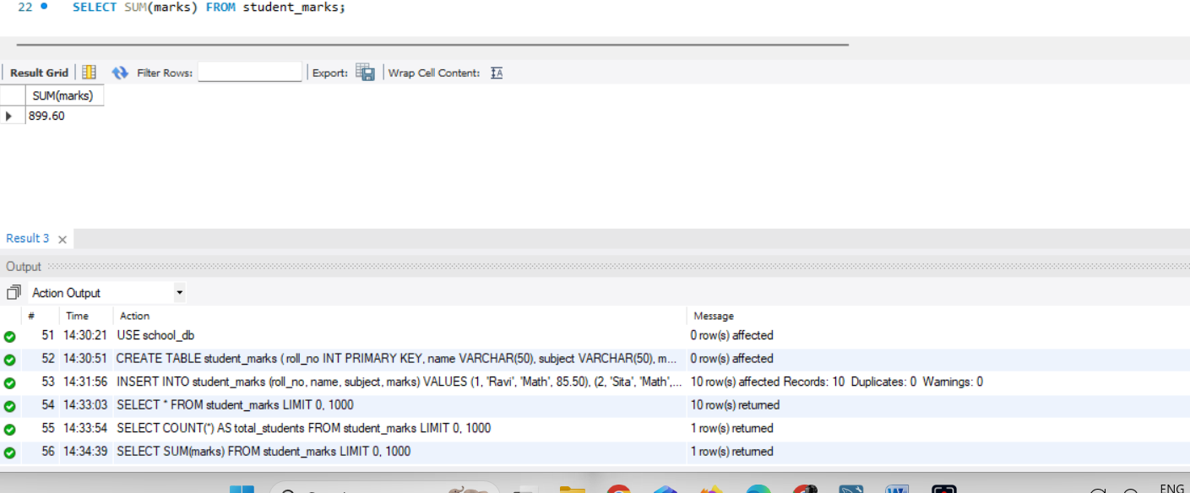
- Average of Marks
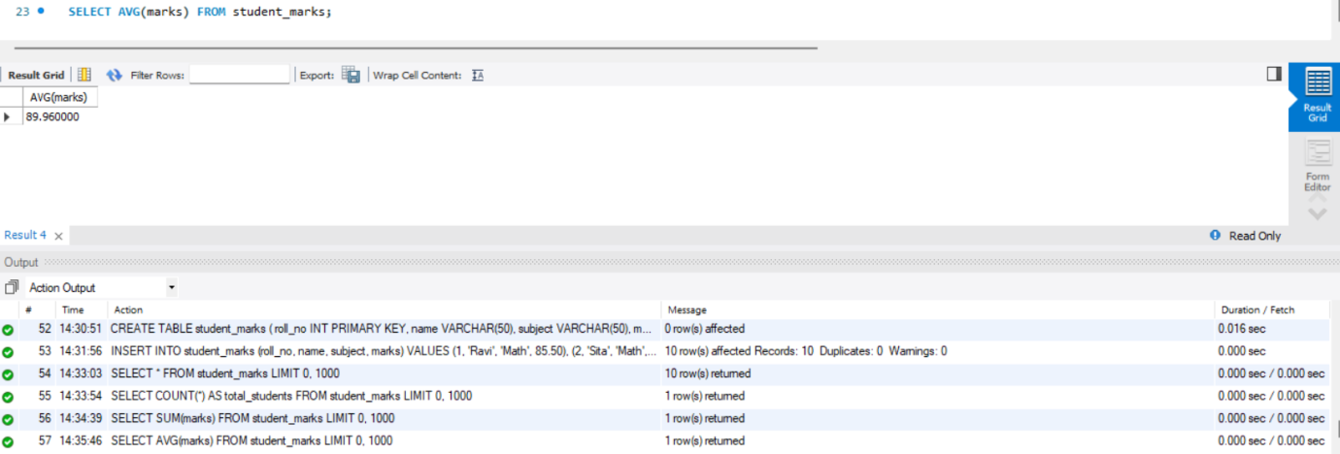
- Highest Marks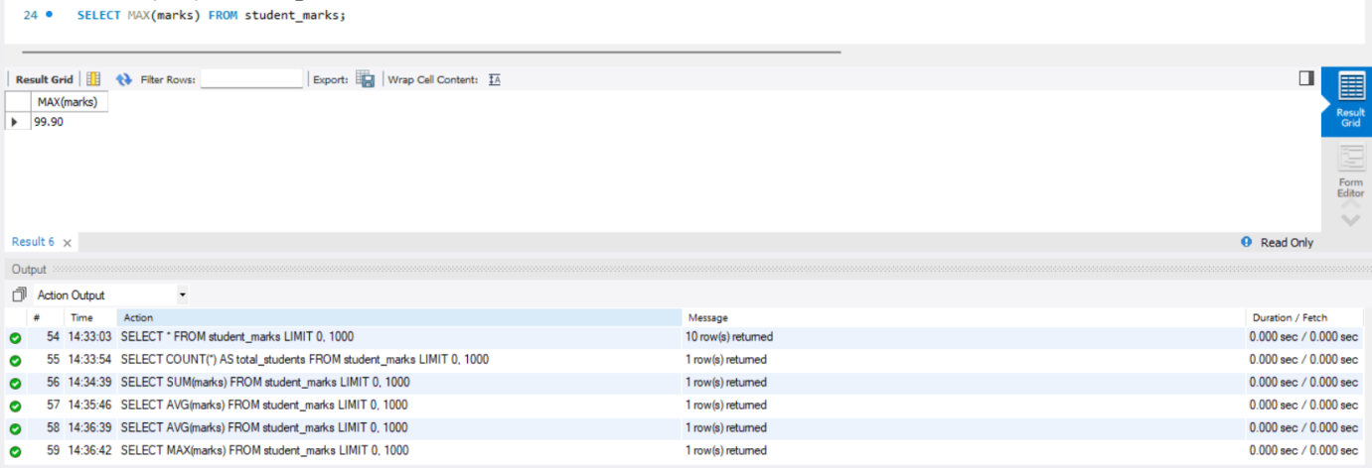
- Lowest Marks
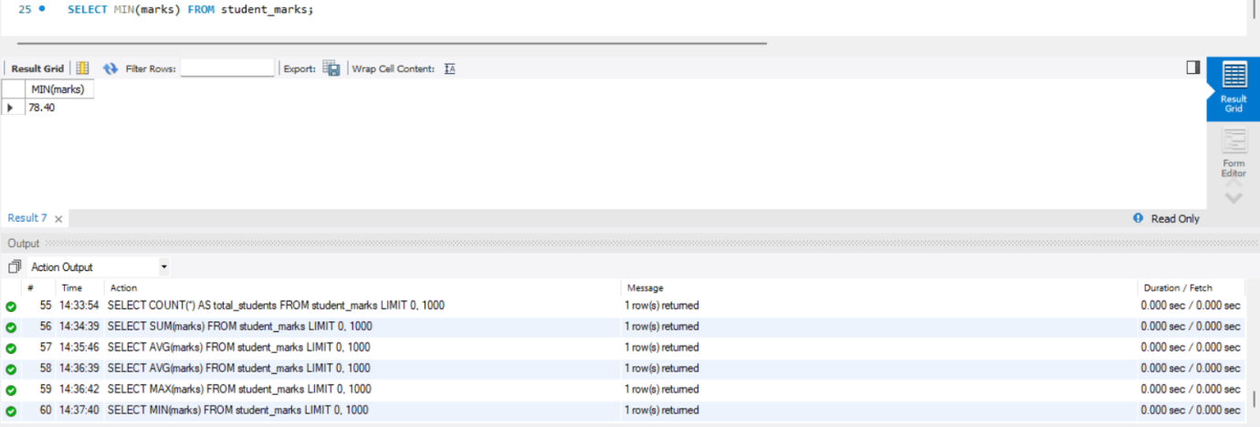
- Filter Marks Above 85
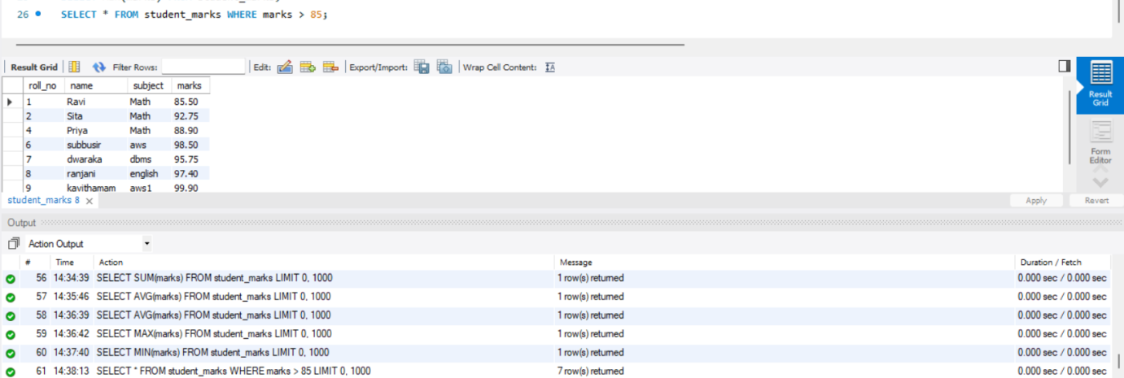
- Filter Marks 90 or Above
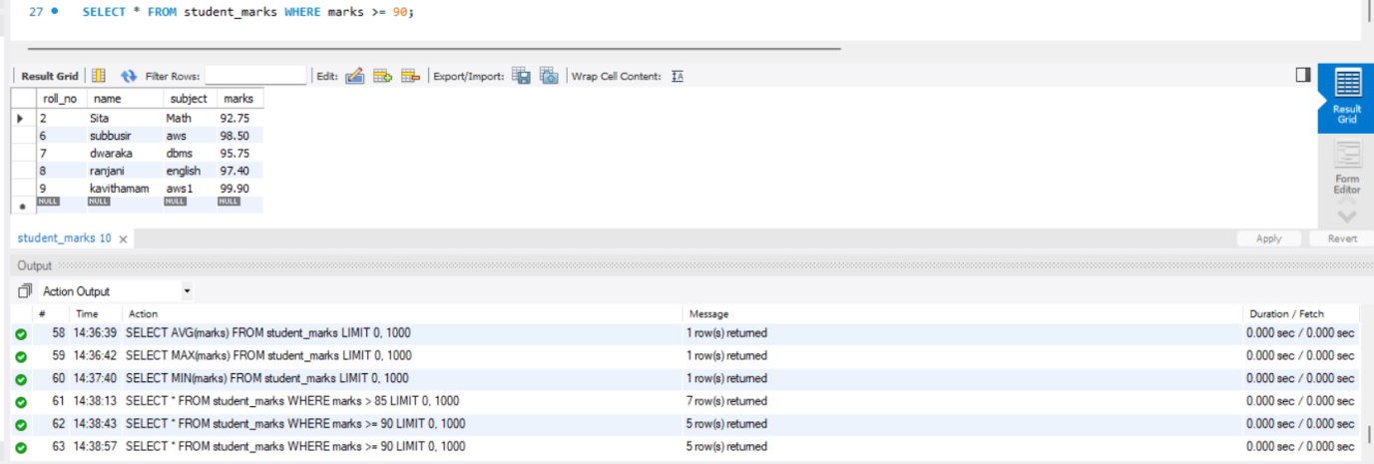
- Filter Marks Below 80
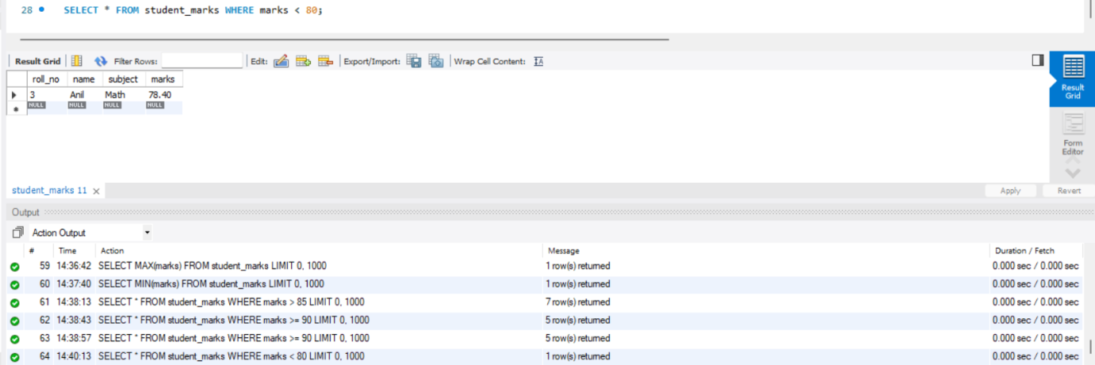
- Filter Marks in Range 80 to 90
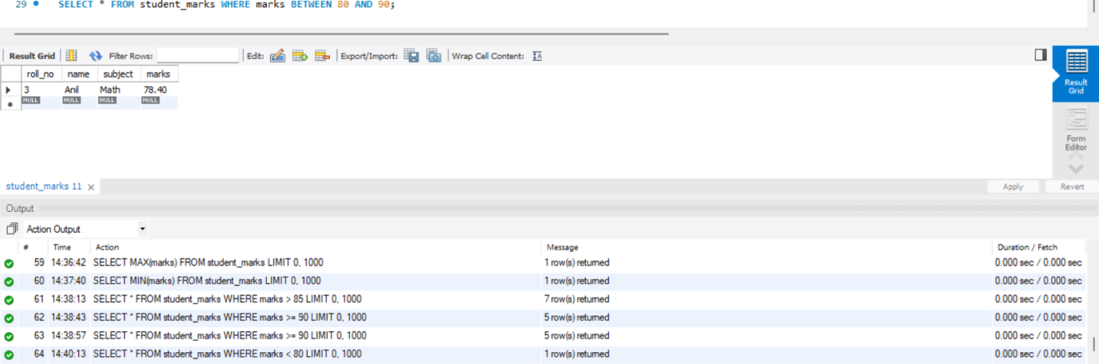
- Filter Name Starting with P
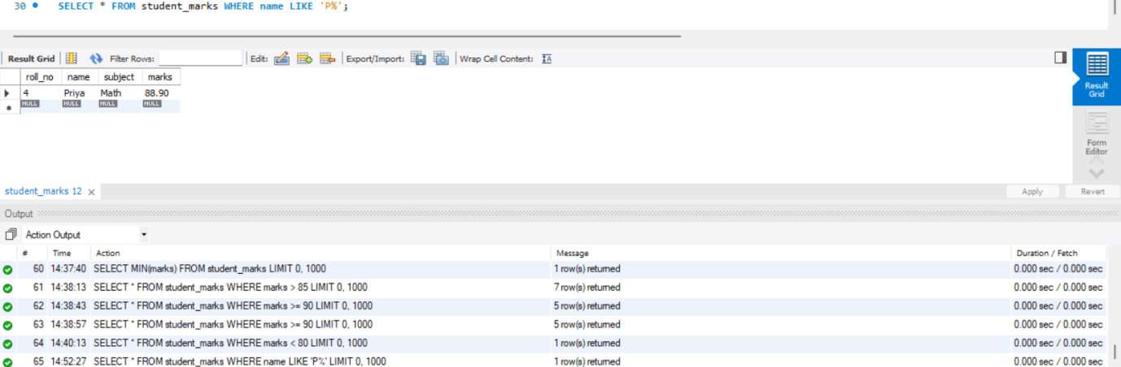
- Filter Specific Names
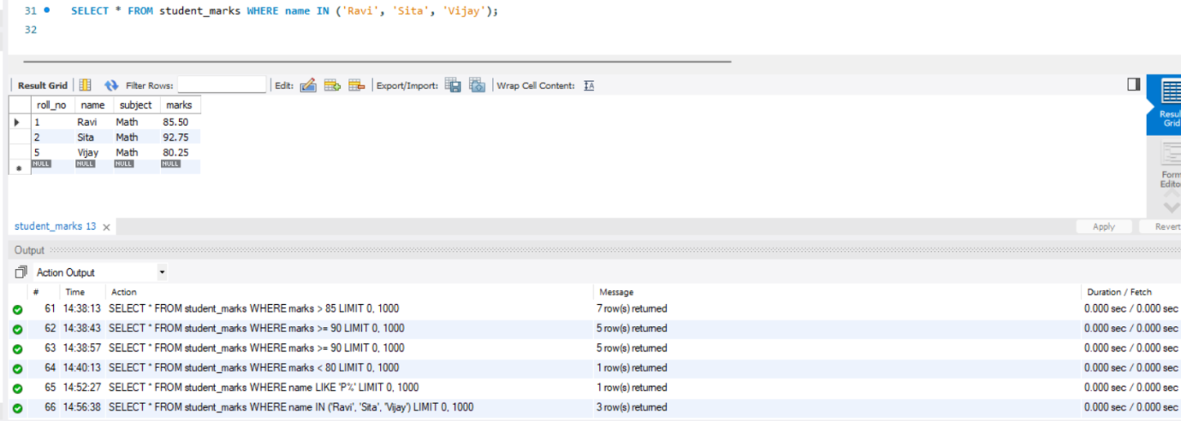
- Filter with Combined Conditions
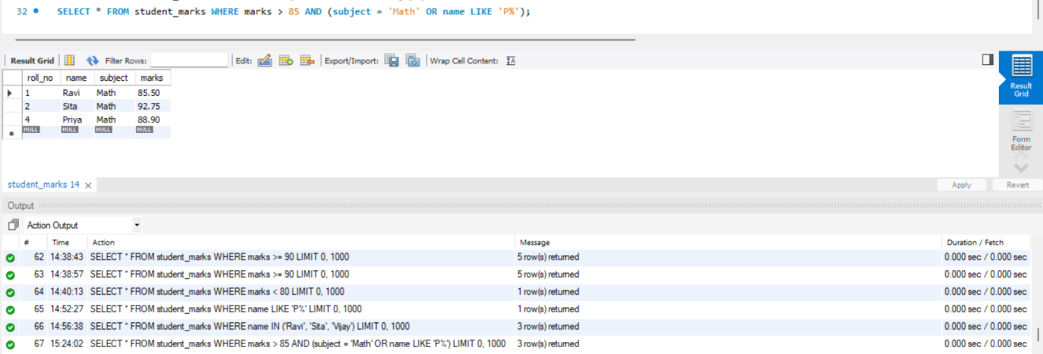
- Update Single Record Marks
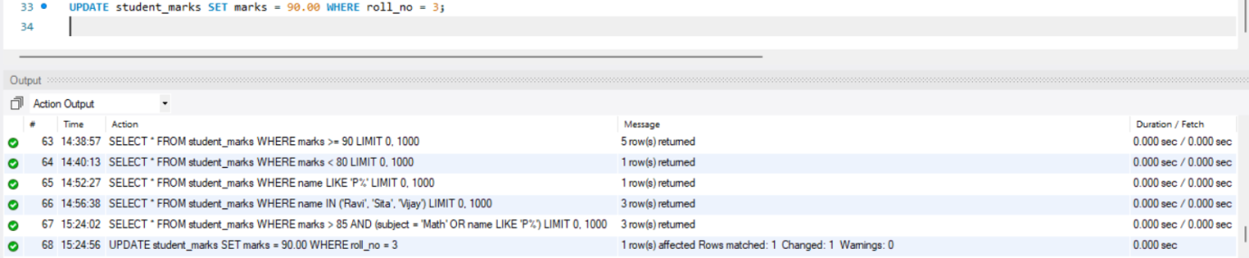
- Conditional Subject Update
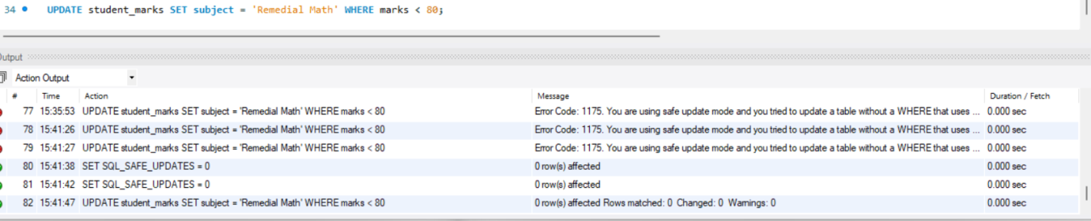
- Delete Single Record
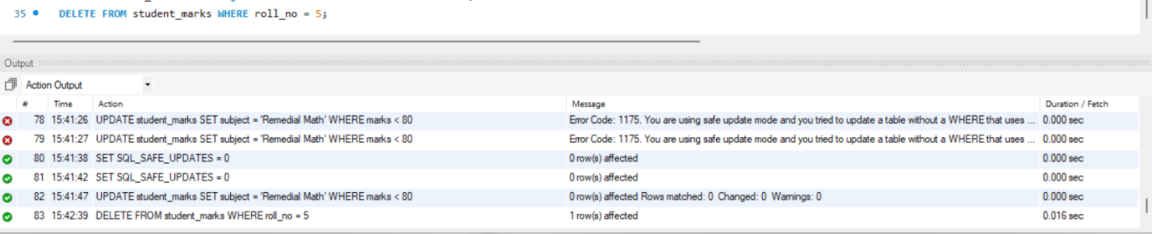
- Conditional Bulk Delete
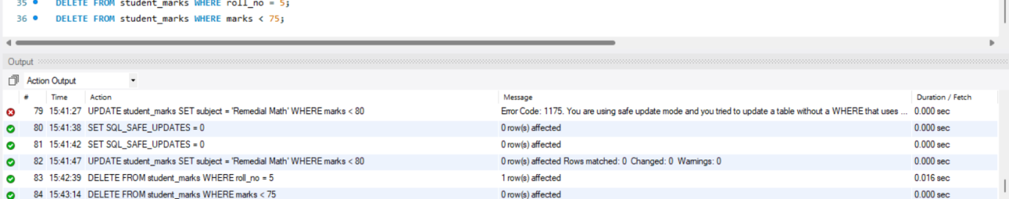
- Sort by Marks Ascending
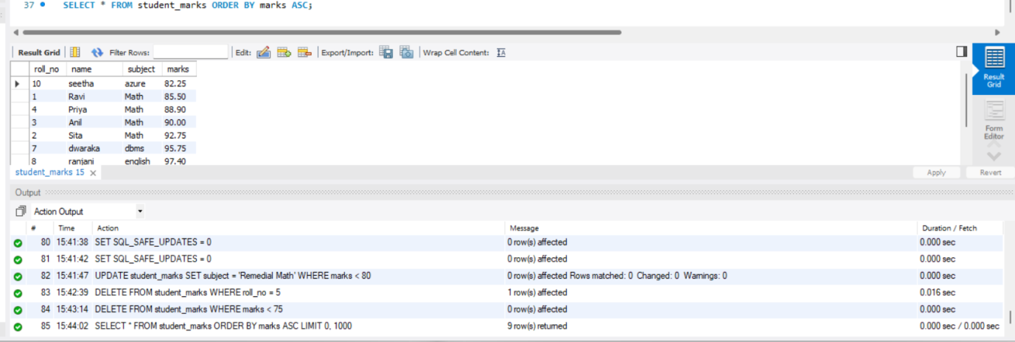
- Sort by Marks Descending
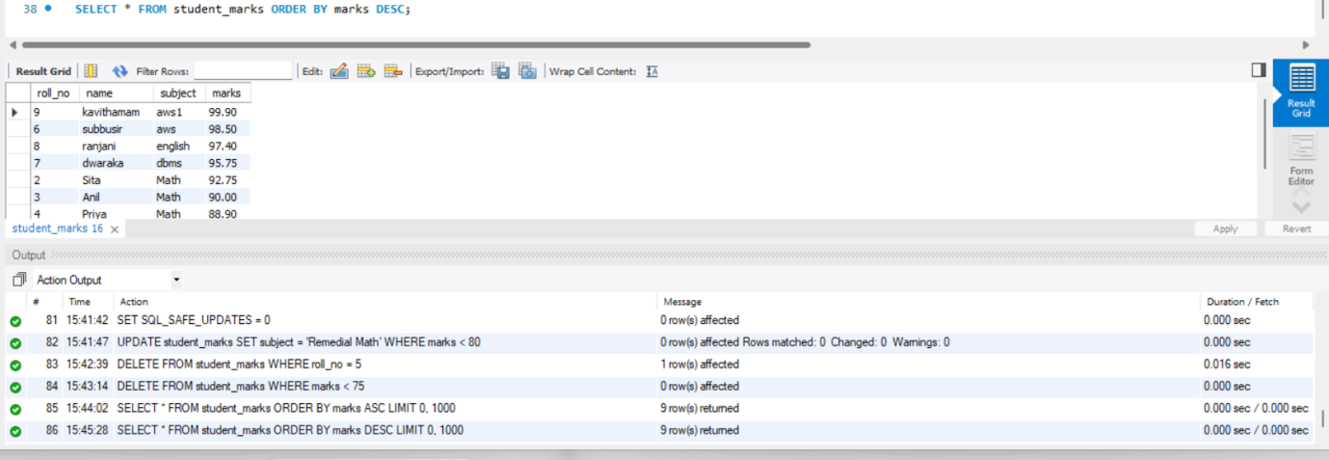
- Sort by Name Alphabetically
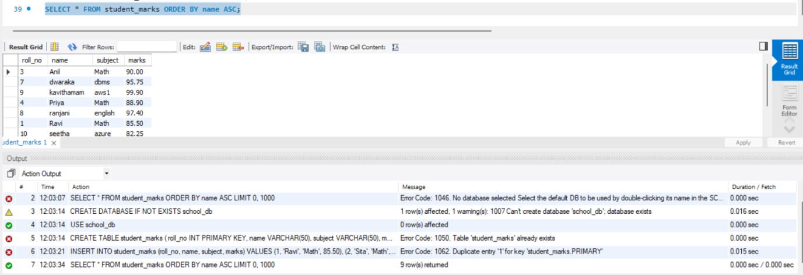
- Sort by Name Reverse Alphabetically
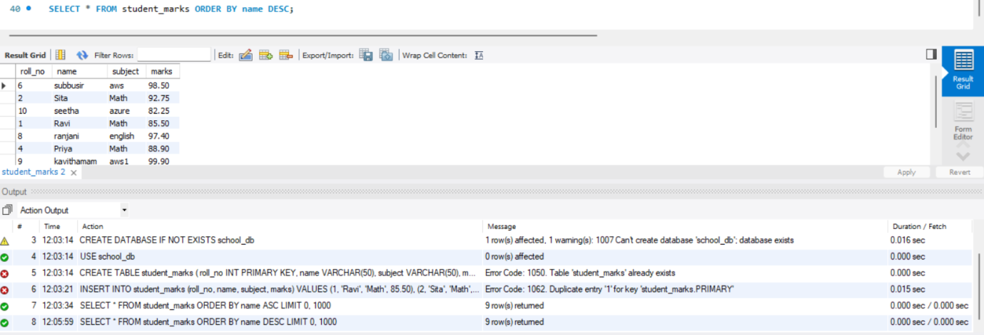
- Total Marks Grouped By Subject
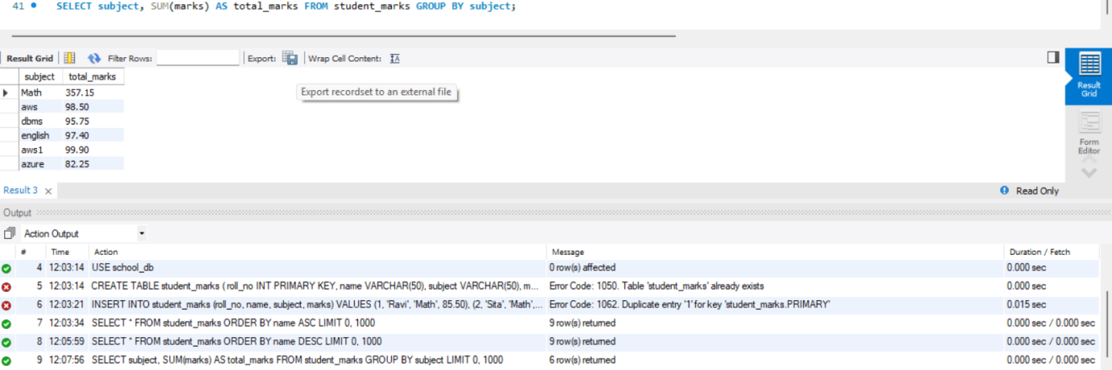
- Average Marks Grouped by Subject
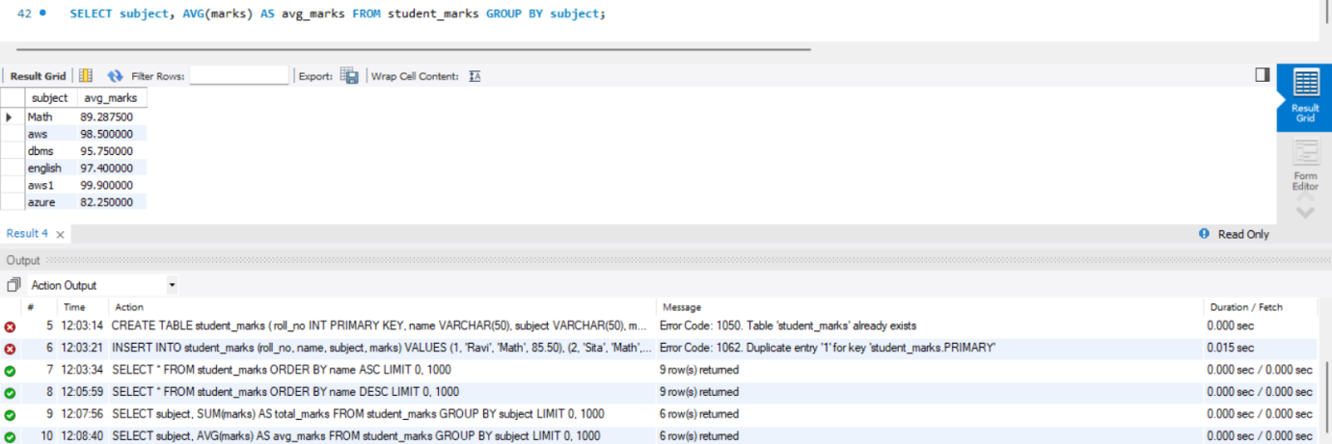
- Student Count Grouped by Subject
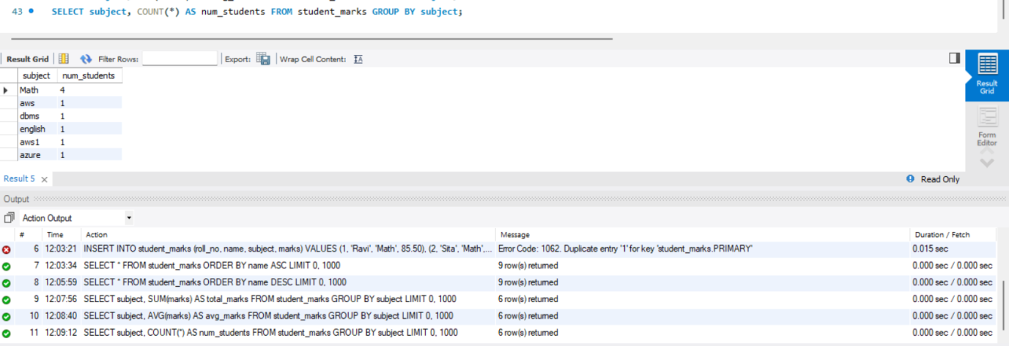
- Filter Groups by Average Marks
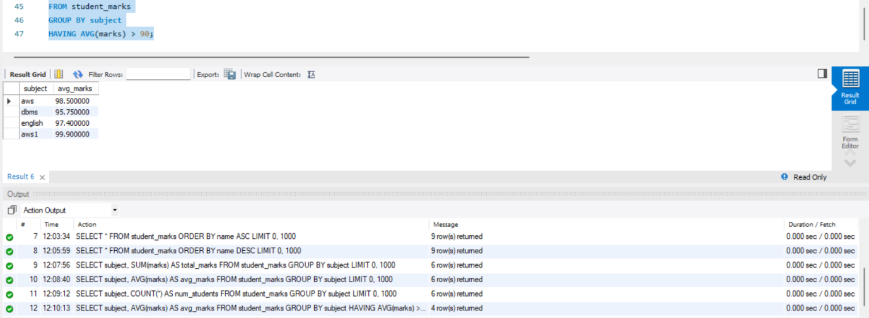
- Filter Groups by Student Count
